ANNEX C
“ACOFA-SUPPLIER REGISTRY”

- Fill this registry in all its parts.

- This form and every additional documentation must be upload with the original signature to the Subdivision of Purchasing Acquisitions in Bogota through the following link:

https://proveedores.fac.mil.co
- Send only the certifications required as annex.

- The data contained in this form and its annexes will be the basis of your Company’s registration.

- The information could be verified to prove its authenticity.

G. All the information included in this form, in order to complete the registration, shall be responsibility of the signer.

1. Name of the Company:
____________________________________________________________________________
2. FEI Number or fiscal identification ____________________________________________________________________________
3. Address: ____________________________________________________________________________
____________________________________________________________________________
4. City: ________________________________________________________________
5. Country: _____________________________________________________________
6. Telephone: ______________ Fax: ______________
Telephone: ______________ Fax: ______________
7. Email (For all communications): ____________________________________________________________________________
____________________________________________________________________________8. Date of Creation and/or Constitution of the Company: ___________________________
9. Name of the Representative or CEO_________________________________________
10. CEO Identification Number_________________________________________________
11. Name of the Agent or legal representative in Colombia: (optional, but Power of Attorney must be provided) ____________________________________________________________
Telephone(s): _________________ Email______________________________________

FINANCIAL INFORMATION (CLOSE LAST YEAR)

12. (Date) _______________

13. Liquidity ratio:
Current assets: USD___________ / Current liabilities USD_____________ = _____________

13. Working Capital
Current assets: USD___________ - Current liabilities USD_____________ = _____________

14. Patrimonial Capacity:
Total Assets USD ________________________
Total Liabilities USD _________________________
Total Equity USD ________________________
Total Assets USD ____________ / Total Liabilities USD _____________ = _________

15. Debt to Equity ratio
Total Liabilities USD _____________ / Total Equity USD ___________ = __________

16. Bank Information (Required space):
a. Bank Name_______________________
b. Account Number___________________
c. Swift Code________________________
d. ABA or IBAN Code__________________

SPECIAL ATTRIBUTES

16. Manufacturing Company: Yes No Explanation______________________________
____________________________________________________________________________
17. Exclusive Manufacturer’s representative (Exclusive distributor): Yes No Explanation___________________________________________________________________
18. Exclusive Supplier: Yes No Explanation___________________________________
____________________________________________________________________________

NOTE: If you answered YES to any of sections 16, 17 or 18, you must complete the Capabilities Report and provide sufficient documents to prove such statements, along with your registration forms.

SUPPLIER'S CAPACITY ACTUALIZATION FORM
(mark with an X) SALE and/or REPAIR
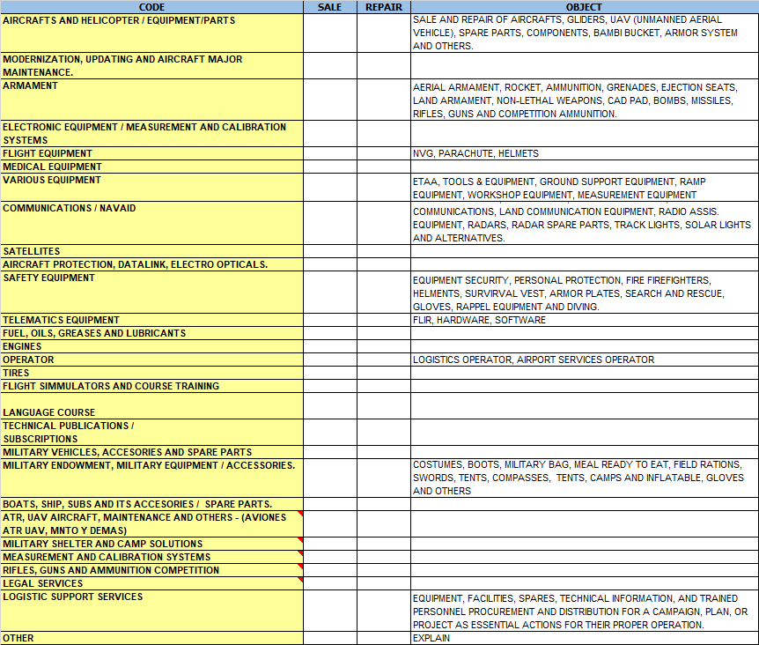

Regards, ___________________________________
Legal Representative (Foreign Company)
Name:
CAPABILITIES REPORT

COMPANY NAME:
CAPABILITY TO REPORT: (mark with an X) |  |  | PARTS DISTRIBUTION |  | COMPONENTS REPAIR

PARTS DISTRIBUTION

DOES YOUR COMPANY HAVE ANY CERTIFICATION IN ACCORDANCE WITH AC No 00-56B?
(mark with an X)

YES |  |  | NO
AS-9100
ISO-9001
ASA-100
TAC 2000
OTHER |  |  | DESCRIBE

DOES YOUR COMPANY HAVE ANY EXCLUSIVE OR AUTHORIZED REPRESENTATION FOR PARTS DISTRIBUTION?
(mark with an X)

YES |  |  | NO
INDICATE FROM WHICH OEM
DOCUMENTS THAT CERTIFY THIS MUST BE ATTACHED FOR EACH CASE.

COMPONENTS REPAIR

DOES YOUR COMPANY OWN A REPAIR STATION CERTIFIED BY FAA OR EASA?
(mark with an X)

YES |  |  | NO
CERTIFICATE NUMBER

THE REPAIR STATION FAA OR EASA CERTIFICATE AND THE LIST OF CAPABILITIES MUST BE ATTACHED

DOES YOUR COMPANY HAVE ANY EXCLUSIVE OR AUTHORIZED REPRESENTATION OF COMPONENTS REPAIR DIRECTLY FROM AN OEM?
(mark with an X)

YES |  |  | NO
INDICATE FROM WHICH OEM
DOCUMENTS THAT CERTIFY THIS MUST BE ATTACHED FOR EACH CASE AND THE REPRESENTATION LIMITATIONS (WITH MODELS OR P/N OF SPECIFIC COMPONENTS) MUST BE DETAILED.

Regards, ___________________________________
Legal Representative (Foreign Company)
Name:

