ANNEX C
“ACOFA-SUPPLIER REGISTRY”

- Fill this registry in all its parts.

B. This form and every additional documentation must be sent with the original signature to the Subdivision of Purchasing Acquisitions in Bogota to the following direction:

COMANDO FUERZA AÉREA COLOMBIANA
Ministerio de Defensa Nacional Comando Fuerza Aérea Colombiana Carrera 57 No. 43-28 Bogotá puerta no.8 cancillería (radicación documentación).
Atención: SUBDIRECCIÓN DE ADQUISICIONES – ACOFA

- Send only the certifications required as annex.

- The data contained in this form and its annexes will be the basis of your Company’s registration.

- The information could be verified to prove its authenticity.

- Response not limited to spaces

G. All the information included in this form, in order to complete the registration, shall be responsibility of the signer.

1. Name of the Company:
____________________________________________________________________________
2. FEI Number or fiscal identification ____________________________________________________________________________
3. Address: ____________________________________________________________________________
____________________________________________________________________________
4. City: ________________________________________________________________
5. Country: _____________________________________________________________
6. Telephone: ______________ Fax: ______________
Telephone: ______________ Fax: ______________
7. Email (For all communications): ____________________________________________________________________________
____________________________________________________________________________8. Date of Creation and/or Constitution of the Company: ___________________________
9. Name of the Representative or CEO_________________________________________
10. CEO Identification Number_________________________________________________
11. Name of the Agent or legal representative in Colombia: (optional, but Power of Attorney must be provided) ____________________________________________________________
Telephone(s): _________________ Email______________________________________

FINANCIAL INFORMATION (CLOSE LAST YEAR)

12. Total Assets USD _____________________________ (Date) _______________
13. Total Liabilities USD ______________________________
14. Total Equity USD _____________________________
15. Bank Information (Required space):
a. Bank Name_______________________
b. Account Number___________________
c. Swift Code________________________
d. ABA or IBAN Code__________________

SPECIAL ATTRIBUTES

16. Manufacturing Company: Yes No Explanation______________________________
____________________________________________________________________________
17. Exclusive Manufacturer’s representative (Exclusive distributor): Yes No Explanation_
____________________________________________________________________________
18. Exclusive Supplier: Yes No Explanation___________________________________
____________________________________________________________________________
NOTE: If you answered YES to any of sections 16, 17 or 18, then sufficient documents to proof such statements must be provided accordingly, along with your registration forms.

SUPPLIER'S CAPACITY ACTUALIZATION FORM
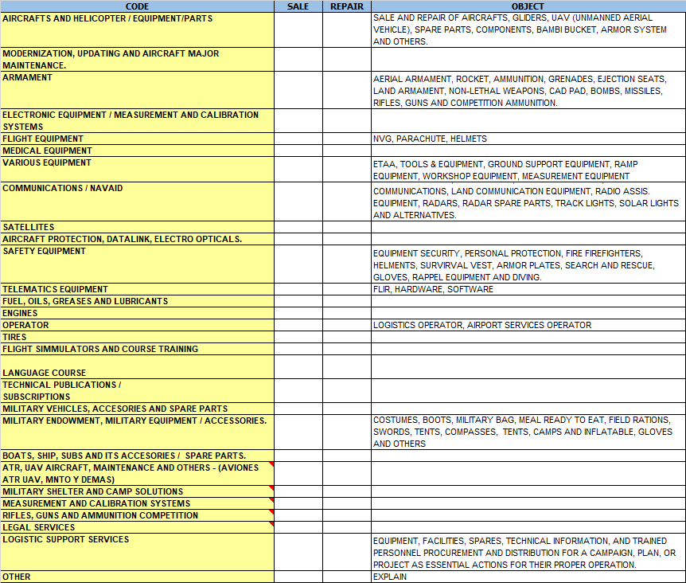

Regards, ___________________________________
Legal Representative (Foreign Company)
Name:

